Sample training program

Introduction to Integrated Water Resource Management (specialised)
“Delivery mode
- Short course

Duration
- 2 weeks (10 days)

Target audience
Designed for professionals who not only require an overview of integrated water management, but who are also seeking to enhance their pre-existing technical skill sets by undertaking a one week specialist elective.

Learning objectives
Understanding of the interconnected nature of water management so that participants are not only able to tackle water problems from a technical position, but also understand environmental, social and economic factors
Understanding of more detailed concepts and approaches of integrated water management through the study of a chosen elective.

Recommended number of participants
30 participants per program (minimum 20 – maximum 40)

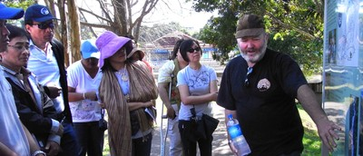

Week 1
- integrated water management | - understand concepts and practice of integrated water resource management and whole-of-water cycle approaches
- project management | - recognise the importance of participatory project management and frameworks for cross-sectoral collaboration within the water sector
- water, sustainability and development | - understand current international development thinking about sustainable development and its application to water and water resources
- water governance and policy | - recognise and be able to apply the basic elements of good water governance as a component of integrated water management
- catchment and aquatic ecosystem health | - working in multi-disciplinary teams, professionals will integrate their learning from day one to five by applying knowledge and skills to specific water-related problems
- integrated water management capacity building workshop | - the interactive workshop will assit in the development of higher order water management skills


Week 2
During the second week a particular area of interest can be studied in greater depth and can be specifically tailored to the participants’ requirements.
The second week elective will involve classroom, field-based and active learning exercises with course delivery by various scientific experts and industry leaders.
The list of electives offered is not definitive. More options can be discussed.
If necessary, translators will be provided.
- integrated water management | - water reform and regulatory tools, legislation
- emerging trends in managing water | - water supply management
- project management | - wastewater treatment technologies and effluent management
- science of water | - wastewater recycling and purification
- water, sustainability and development | - groundwater management
- water governance and policy | - environmental flow methodology
- catchment and aquatic ecosystem health | - water in mining
- capacity building and community development | - river restoration
- water planning and economics | - water and climate change
- stakeholder engagement and community development | - sustainable sanitation

